Arrangement and Description: Fundamentals
Day 1: Arrangement

8:45-9:00 Registration
9:00 Goals of arrangement and description
Principles of arrangement
    - Respect des fonds, provenance and original order
    - Nature of archives and manuscripts
    - Levels of arrangement
Preparing for arrangement
    - Processing work plans or checklists
    - Estimating processing rates
    - Notification of processing
Physical arrangement
    - Preliminary research
    - Determining series/subseries
    - Common arrangement schemes
Personal/Family papers
Literary papers
Organizational/Business records
Legislative papers
Judicial records
    - Arrangement of specific record types
Audiovisual materials
Correspondence
Photographs
Printed materials
Writings (manuscript/typescripts)
Additional/Other papers (Misc.)
- Electronic records
- Sorting
- Collecting descriptive notes during processing
- Separating materials
- Weeding
- Restricting materials
- Preparing file folders/boxes
Additional techniques
    - Minimal processing
Preservation during processing
4:30 Questions and wrap-up

Arrangement & Description (A&D)
Certificate Program

Offered by SAA:

    - Foundational Courses - must pass 4
    - Tactical and Strategic Courses - must pass 3
    - Tools and Services Courses - must pass 1
    - Transformational Courses - must pass 1

Course examinations are administered online.

For more information: http://www2.archivists.org/prof-education/a-d

Goals of Arrangement and Description

Arrangement
Arrangement is the process of physically organizing materials with respect to accepted archival standards. Each collection is unique, and the amount of arrangement that is necessary will vary. Some collections may still be in their original order, while others will need extensive arrangement to restore the original order or to impose a new order if none previously existed. The arrangement of a collection involves the identification and organization of its various parts.

Three phases:

- Determining the intellectual placement of the papers or records (e.g., University archives or manuscript collection)

- Examining the records to determine their existing order and devising a plan for arrangement

- Processing or physical arrangement of the records

Collections must be arranged before they are described, since the pattern and level of arrangement will influence the level of description that follows.

Description
The major objective of description is to establish the intellectual control of a collection. Description involves recording information about the nature and content of records. Like arrangement, description is performed at a variety of levels. Descriptive work may be necessary upon the receipt of a new collection, an addition to an existing collection, or the completion of a processing project.

The creation of descriptive tools, such as finding aids, subject guides, names indexes, MARC records, and Encoded Archival Description (EAD) records, are the bridge that connect users to collections.

The Happy Medium
The level of arrangement and description is a compromise between access and staff time and resources. The level of arrangement and description should provide good access to the material without spending inordinate amounts of time examining and reading every item in a collection. If you choose to do this - you will never get done!
Respect des Fonds, Provenance and Original Order

Respect des Fonds

The principle that the order of the records created, accumulated, assembled, and/or maintained and used by an organization or individual must be kept together in their original order if it exists or has been maintained and not be mixed or combined with the records of another individual or corporate body. [DACS]

Historic factoid: In 1830, François Guizot, French Minister of Public Instruction, issued regulations requiring the application of respect pour les fonds to the records of the départements in the Archives Nationales.

Provenance

The relationships between records and the organizations or individuals that created, assembled, accumulated, and/or maintained and used them in the conduct of personal or corporate activity. [DACS]

Things to Consider:

- DO NOT commingle records from different creators or donors.

- DO NOT create a vertical file with related materials from various collections.

- DO NOT remove correspondence from one collection and place in another collection.

- DO NOT arbitrarily divide and reorganize materials on other principles such a geographical focus, subject matter, or time period.

- Provenance serves as the basis for authenticating and assuring the reliability of the contents of the records.

Historic factoid: In 1881, the Prussian State Archives issued precise regulations on arrangement that defined Provenienzprinzip, or the principle of provenance.

Original Order

The principle that the order of the records that was established by the creator should be retained whenever possible to preserve the existing relationships between the documents and the evidential value inherent in their order. [DACS]

Things to consider:

- Whenever possible, records should be kept in the order in which they existed.

- When a pre-existing internal organization is not apparent, or is actually counterproductive to the effective analysis and use of the collection, one must construct a rational order that is sensitive to the nature and uses of the collection.

- Rearrangement should be only undertaken after research, careful consideration and "trying out" the proposed arrangement pattern on a colleague or researcher to assess its merits.

Historical factoid: The Prussian archivists of the mid-19th century expanded the influence of the office of origin by developing and establishing the related Principle of Original Order or Registratorprinzip in German.

The Manual on the Arrangement and Description of Archives, written in 1898 by Dutch archivists Muller, Feith, and Fruin, brought together the French and Prussian ideas of respect des fonds, provenance and original order.

Provenance and original order are important because:

- It helps to preserve context and coverage of the records themselves.
- It helps to preserve information on the attitudes reflected by the records.
- It protects the conditions under or during which records where created.
- It protects the actual information in the records.
- It serves as a way to authenticate and provide reliable documentary evidence of the records.

Nature of Archives and Manuscripts

Archives are the permanently valuable records received and accumulated by formal organizations such as non-profit organizations, businesses and governments in the process of conducting their daily business.

Examples:

- British American Tobacco Company records
- Cook County (Ill.) County Auditor. Tax exempt properties records
- English State Company at the Royal Court Theatre correspondence
- St. Paul African Methodist Episcopal Zion Church records
- University of California, Irvine, Office of Research and Graduate Studies records

Manuscripts are the personal or literary records of people and families created, received, assembled, or accumulated as they conducted their daily personal activities.
Examples:
- Andrew Swanson family papers
- James Joyce papers
- James M. Woodbury diary
- Paul Hibbet Clyde and Mary Kestler family papers
- Troy Kinney etchings and engravings

Oliver Wendell Holmes'

Levels of Arrangement

Repository level
The repository is simply the archives itself and its collection areas. Some archives may maintain distinct collection areas, such as a state government records, local government records, manuscript collections, or university archives (official records of the university).

Record group/Collection level
A record group is a body of records created or kept by a person or an organization. Each record group will contain only materials created by, received by, or pertaining directly to one individual or distinct group.

Series level
The next level, series, is simply a grouping of records according to their physical type, subject, or filing unit. The series level best illustrates the actual activities of the creator. Series may also be further divided into subseries. Subseries are always directly related to their respective series. For example, a correspondence series may contain two types of correspondence; business and family. In this case, two subseries - business correspondence and family correspondence - should be established within the correspondence series.

File level

The file level contains organized units of documents, accumulated during use and kept together because they deal with the same subject, activity, or transaction. Many records, especially those of organizations or businesses, will have been filed according to an established system. Maintain this system (original order) as long as it is consistent and logical. Personal papers may have no discernable order and they might not have even been filed, in which case you will have to organize them. Files are commonly arranged within a series alphabetically, chronologically, numerically, or by record type.

Item level
The item is simply the individual record, the letter, photograph, diary, or audiotape. The letters in a folder may be arranged by record type, by date, or alphabetically by subject.

Example:
Repository: Manuscript Collection
Collection: Ted Hughes papers
Series: Correspondence
Subseries: Alphabetical correspondence files
File: Adams-Catlin
Item: Adams, James to Ted Hughes, March 14, 2001

Example:
Repository: State Government Records
Record Group: Office of the Governor
Series: Governor Sherman Oaks schedules and appointment files
Subseries: Schedules
File: November-December 1981
Item: Schedule for November 11, 1981

Processing Work Plan
[Source: Emory University, Manuscript, Archives, and Rare Book Library]

Collection-level analysis
● Collection number: 1131
● Creator: Bullins, Ed
● Title statement: Ed Bullins papers
● Date span: ca. 19
● Extent: 29 linear feet (29 boxes)
● Collection history: Ed Bullins is a prolific African American playwright. MARBL purchased the collection in early 2010.

● Restrictions:
Yes No

● Disposition of duplicates/unwanted material:
Return to donor Shred

Arrangement:
The material was boxed up by Randy Weinstock, of the Wheatley Center in Massachusetts. According to Randall, the material may have had some order, but Mr. Weinstock probably disorganized it as he packed it. It appears that Bullins kept a filing system - almost every box contains files in folders, but the arrangement of these folders seems very haphazard. Play manuscripts will be found next to correspondence, next to printed material, etc. [After a little investigating, I've determined that Bullin's biographer, Samuel Haywood, had possession of the papers for quite some time in the late 1980s up to the mid-1990s. The filing "system" may be Haywood's, not Bullins]. Will most likely dissemble and sort by standard series types.

- Correspondence (break up the small alpha runs, and do chronological)
- Writings
  - Plays (alpha) [remove printed material from the files - these will go into the printed material series]
  - Other writings (novels, essays, others)
- Writings by others
- Subject files (this is everything else that didn't fit into the other categories - much of these will be weeded, but I'm thinking it will fall nicely into alphabetic subject files)
- Printed material (by, about, general)
- Photographs
- Audiovisual

Description:
Mostly folder level

Preservation Concerns:
None at present
Series-Level analysis [Duplicate for each series]

● Series title: Writings

● Arrangement:
- Subseries: Play scripts [arranged alphabetically by play title]
- Subseries: Other writings [arranged by type - probably as bolded headers depending on how many of each type]

● Extent: 10 linear ft. (10 boxes)
Current: Proposed:
Alphabetical Alphabetical
Chronological Chronological
Numerical Numerical
By record type By record type
Other: _________________________ Other: _______________________
No arrangement
Comments:

● Proposed level of arrangement:
Collection level Box level Folder level Item level
Comments:

● Proposed level of description:
Collection level Box level Folder level Item level
Comments:

● Proposed preservation during processing:
Rebox
Refolder
Flattening
Hardware removal
Unbind post binders/loose-leaf notebooks
Sleeve photographs
Other:
Comments:

● Estimated Processing time (using Projected Processing Rate):

● Actual Processing time: Beginning date: 8/21/15 Scheduled end date: 12/21/15 Actual end date: 11/25/15

● Decisions
File multiple versions of the same script in a single folder.

Processing Plan
[Source: Special Collections Research Center, Southern Illinois University Carbondale]

Collection number: PP 34 Creator: Burris, Roland W.
Title Statement: Roland Burris senatorial papers
Date Span: 2009-2011 Extent: 100 cubic feet

REVIEW OF DEED OF GIFT:
Possible restrictions: Donor maintains copyright
Discarding of extraneous materials: Dispose by staff in accordance with Illinois state law

COLLECTION ANALYSIS:
Current arrangement (Alpha, Chron, Numerical, By record type, Other: or No Arrangement)
Arranged by office function

Physical condition (formats, condition): electronic records currently on CDs; overall good condition

Languages other than English: None Potential discards: duplicates; awards

Addition to existing collection? No

PLAN:
Arrangement Scheme: By series and within each series (proposed arrangement: Alphabetical, Chronological, Numerical, By record type, Other)
Description Scheme: (collection, series, box, folder, item)

Series 1. Legislative records Arr. Alphabetical by committee Lev. folder
Sub 1.1. Defense and Foreign Affairs Arr. Alphabetical Lev. folder
Sub 1.2. Education Arr. Alphabetical Lev. folder
Sub 1.3. Health and Veterans Arr. Alphabetical Lev. folder
Sub 1.4. Homeland Security Affairs Arr. Alphabetical Lev. folder

Series 2. Scheduling Arr. By record type Lev. box
Sub 2.1. Daily schedules Arr. Chronological Lev. box
Sub 2.2. Invitations, accepted Arr. Chronological Lev. box

Preservation Work: copy electronic records onto server; refolder materials in 3-ring binders
Staff assignments/Team assignments: EC/WR
Estimated processing time: 10 weeks Supplies required: archival folders

NOTES:
Review of awards and other memorabilia

Submitted by: Date of plan:
Approved by: Date:
Processing Checklist
[Source: Special Collections & Archives, Georgia State University]

Collection Number: | Creator:
Title Statement: | Date Span:
Extent: | Processor:
Activities Completed:

Background research
Review of collection file
Processing plan completed and approved
Arrangement completed
Holdings maintenance (replaced folders and boxes)
Preservation / Physical repairs
Finding aid draft
Container list
Folders and boxes labeled
EAD finding aid encoded
MARC21 record
Review finding aid and catalog record
Finding aid web output enabled
Finding aid copy placed in reading room
Finding aid copy placed in collection file
Collection shelved
Update storage/shelf location
Update collection file
Email notification to reference staff
Donor notification
Publicity

Notes:

Beginning date: | Completion date:

Estimating Processing Rates
[Source: Beinecke Rare Book and Manuscript Library processing manual]

One of the most difficult tasks archivists face is that of accurately estimating how long it should take to process, arrange, and describe collections of personal papers. The following guidelines may be helpful in making such determinations.
Processing rates vary a great deal from collection to collection. The following guidelines have been found to be both useful and reliable. It must be noted, however, that processing estimates are derived from preliminary examinations of collections of papers. It is always possible, therefore, that complications will be found during processing that were not anticipated at the time of the survey. In addition, it may be expeditious to vary levels of processing by series or subseries based on their projected use or value to researchers.

In determining processing rates, all time is considered equal. (Not all processing requires the expertise of trained archivists, so efficiencies can be achieved by matching tasks to levels of skill and expertise of available staff.) Some tasks should only be undertaken by trained archivists, while other tasks like sorting, preservation photocopying, inputting, numbering, and some listing can be done by clerical assistants, students, interns, or volunteers. The greater the expertise of support staff, the wider the range of duties that can be assigned to them.

OPTION 1
These processing times are based in part on Karen Temple and Thomas E Lynch's article, "Rates of Processing Manuscripts and Archives," in The Midwestern Archivist, Vol. 7, No. 1, 1982, pages 25-34.

Rate | Estimate | Description
A | 40 hours per linear ft. | Used for collections that have to be described at the item or virtually at the item level, like autograph collections.
B | 30 hours per linear ft. | Used for collections that have little or no arrangement and order. Different kinds of materials are mixed together, correspondence is unsorted or stored in original envelopes, some papers and correspondents are unidentified, and extensive preservation work may be required.
C | 20 hours per linear ft. | Used for collections that have an average number of problems. Papers may have some order and sections of the collection may be properly sorted, although significant portions will have to be arranged and a good deal of interfiling work will have to be done. Most collections can be processed at this rate.
D | 10 hours per linear ft. | Used for collections that have no significant organizational problems. A minimum amount of interfiling and reorganization is needed. Records of organizations and collections that consist primarily of manuscripts of published works often fall into the D category.
A preliminary analysis of a collection may indicate that the degree of processing difficulty may fall between two categories.

Rate | Estimate
A/B | 35 hours per linear ft.
B/C | 25 hours per linear ft.
C/D | 15 hours per linear ft.

Total processing time is determined by multiplying the estimated linear footage by the processing rate.

Total linear ft. (multiplied by) | Processing rate (equals) | Total no. of hours needed
40 linear ft. x | 20 hours per ft. = | 800 hours

Total no of hours needed (divided by) | Total no. of team hours per week (equals) | Estimated time
800 hours ÷ | 20 hours a week = | 40 weeks or 10 months

OPTION 2

Type and Date Range of Record per Cubic Foot
Full processing (includes flat-filing, arrangement, description, foldering, and boxing)

Pre-1800 Personal Papers | 9 days
Pre-1900 Personal Papers | 5.5 days
Post-1900 Personal Papers | 3.5 days
Pre-1800 State Government | 4.25 days
Pre-1900 State Government | 2.75 days
Post-1900 State Government | 1.1 days
Pre-1800 Business | 4.25 days
Pre-1900 Business | 2.75 days
Post-1900 Business | 1.25 days
Pre-1800 Local Government | 7 days
Pre-1900 Local Government | 4.5 days
Post-1900 Local Government | 2.25 days
Pre-1800 Mixed types | 8.5 days
Pre-1900 Mixed types | 5.5 days
Post-1900 Mixed types | 3.25 days

More Product, Less Process (MPLP)

Average processing rate (hours per linear foot) given level of processing effort and condition of the materials [From University of California's Guidelines for Efficient Archival Processing, 2012. http://libraries.universityofcalifornia.edu/groups/files/hosc/docs/ _Efficient_Archival_Processing_Guidelines_v3-1.pdf ]

 | Poor condition or many barriers to access | Average condition or moderate barriers to access | Excellent condition or few barriers to access
Minimal effort-Collection level | 1-3 | 1-2 | 1
Low effort-Series or Subseries level | 4-8 | 3-6 | 2-4
Moderate effort-File level (expedited) | 9-14 | 7-11 | 5-8
Intensive effort-Folder level | 15-21 | 12-17 | 9-13
Highly intensive effort-Item level | 22+ | 18+ | 14+

Notification of Processing

Before starting a processing project, be sure to alert other members of your repository's staff, as well as potential researchers that a particular collection is being processed. This can be accomplished in several ways:

- Email: Notify all staff that the collection is being processed. You will need to decide if your in-process collections will be closed to researchers or if arrangements may be made between the reference staff, researcher, and the processing archivist to in-process collections in a manner that also permits the processing archivist to carry out his/her work in an orderly and timely fashion.

- Finding aid: If the collection has an existing finding aid, (1) place a Post-It Note with the processor's name on the paper copy of the finding aid at the reference desk stating that the collection is in process and (2) add the word "Draft" to the file name of the finding aid [i.e. woodruff10 [DRAFT].doc] and the finding aid itself [this ensures that no one distributes to the public]

- Shelf list: Add "IN -PROCESS: [processing team name]" in the note field

- MARC and EAD records: Place the following language in the <accessrestrict> element of the EAD record and the 506 field in the catalog record:

"In-process collection. As of [Month, Year], this collection will be closed to researchers, and will reopen when processing is complete."

"In-process collection. As of [Month, Year], this collection will be closed to researchers, and is projected to reopen [Month, Year].."

- When the processing project is completed, don't forget to:
  - delete the shelf list in-process note
  - delete the word "Draft" from the file name of the finding aid
  - update MARC and EAD records
  - notify staff via email that the processed collection is available
  - Inform donor

Preliminary Research

The first phase in arranging a collection is becoming familiar with the subject matter of the collection. Provenance may have already been established by the information gleaned from the preliminary intellectual survey of the records during accessioning. If not, then the records should be examined more closely to determine the actual provenance.

Knowledge of the agency, organization, or person who created the records will help you have a better understanding of the records. In some instances, the records themselves may shed light upon the creator, such as the annual reports of an agency or organization, genealogical materials of an individual, etc. If the information is not complete enough, other sources or the donor may need to be consulted for more information. This information will eventually be required for the description phase.

Possible sources of information include:

Donor/dealer information

Published works
Who's who publications
Biographical printed works
Local histories
Directory of Organizations

Your library's electronic resources [various databases, etc.]

Internet resources
- Ancestry.com [subscription service, includes Social Security Death Index, Census records, military records, etc.] <www.ancestry.com>
- Civil War Soldier and Sailors System (CWSS): < http://www.nps.gov/civilwar/soldiers-and-sailors-database.htm />
- Biographical Directory of the United States Congress <bioguide.congress.gov/biosearch/biosearch.asp>
- FamilySearch [LDS genealogy site includes Social Security Death Index] <www.familysearch.org>
- USGenWeb Project [sites for individual states and counties] < http://usgenweb.org/>
- Internet browsers (e.g., Google, Yahoo, etc.)
- Newspaper Archive: <newspaperarchive.com/>
- Political Grave: <politicalgraveyard.com>
- Find a Grave: < http://www.findagrave.com/ >
- State archives and local historical society's websites
- WorldCat: <www.worldcat.org>
Determining Series and Subseries

The overall size and complexity of the collection, will help determine whether the use of series and subseries are necessary. Collections that are less than 5 linear ft. usually do not necessitate the use of formal series divisions. Instead, simply group the material by record type.

For larger collections the use of series is generally recommended. Series are usually arranged alphabetically (e.g., correspondence, subject files), numerically (e.g., case files), or chronologically (e.g., correspondence, diaries, minutes). Artificial series can be created for photographs, audiovisual materials, printed materials, and electronic records. Often specific types of collections [e.g., literary papers, family papers] utilize the same types of series.

Series may also contain subseries, which are further divisions of the series. Subseries are directly related to their respective series, for example, a correspondence series may contain two distinct types of records, family correspondence and business correspondence.

Grouping by Record Type

Birdwatchers of America records

Correspondence
1970-1975
1976-1980
1981-1995

Minutes
1910-1930
1940-1960
1970-1990

Scrapbooks
Indigo Buntings
Scarlet Tanagers
Cedar Waxwings

Groupings by Series/Subseries

Salman Rushdie papers

Series 1 Journals, appointment books, and notebooks

Series 2 Writings by Rushdie
Subseries 2.1: Fiction
Subseries 2.2: Nonfiction
Subseries 2.3: Scripts
Subseries 2.4: Other writings

Series 3 Writing by others
Subseries 3.1: Writings about Rushdie
Subseries 3.2: Other writings

Series 4 Correspondence
Subseries 4.1: Family correspondence
Subseries 4.2: General correspondence
Subseries 4.3: Literary agent correspondence

Series 5 Personal papers
Subseries 5.1: Financial records
Subseries 5.2: Legal papers
Subseries 5.3: Family papers

Series 6 Subject files

Series 7 Photographs
Subseries 7.1: Salman Rushdie
Subseries 7.2: Other people and places
Subseries 7.3: Slides and negatives
Subseries 7.4: Family photographs

Series 8 Printed material
Subseries 8.1: Printed material by Rushdie
Subseries 8.2: Printed material about Rushdie
Subseries 8.3: General printed material

Series 9 Audiovisual
Subseries 10.1: Audio recordings
Subseries 10.2: Video recordings

Common Arrangement Schemes

The following arrangement schemes are offered as a general guideline for the types of records or record series and subseries that are found in different types of manuscript collections. For ease of access, the record types are listed in alphabetical order under each category. When determining the final order of the records, the records can be ordered from most important (e.g., correspondence, minutes) to least important (e.g., printed material, ephemera) or simply in alphabetical order.

For large, complex collections, decisions will also have to be made regarding the internal ordering of each record type. If the collection is small, the records may be arranged in alphabetical order by record type.

Personal/family papers
Audiovisual materials (audio and video recordings)
Correspondence (incoming and outgoing letters, postcards, letterpress copybooks, telegrams, etc.)
Diaries/Journals
Ephemera
Financial records (account books, budgets, ledgers, etc.)
Genealogical records
Legal documents (marriage/death records, deeds, wills, etc.)
Organizational files (relating to service on organizations/associations)
Photographs
Printed materials (brochures, certificates, clippings, pamphlets, programs, proofs, etc.)
School records
Scrapbooks
Subject files
Writings (manuscripts, memoirs, reminiscences, reports, research notes, sermons, speeches, etc.)

Literary papers
Audiovisual materials (audio and video recordings)
Correspondence
Alphabetical correspondence files
Business correspondence or Publishers correspondence
General correspondence
Ephemera
Financial records (relating to the business of writing)
Writings [manuscript and typescript]
Writings by [creator]
Notebooks
Type of writing [poetry, prose, translations, etc.]

Writings about [creator]
Writings by others
Printed material [published]
Printed material by [creator]
Printed material about [creator]
Other printed material
Photographs
Subject files

Organizational/Business records
Young, Sandra Florand, Don't Throw it Away: Documenting and Preserving Organizational History, University of Illinois at Chicago, 2006.
<http://www.uic.edu/depts/lib/specialcoll/pdf/DTIA.pdf>

Administrative records
Annual reports
Audiovisual materials
By-Laws and Articles of Incorporation
Committee files
Correspondence
Financial records
Legal records
Meeting files
Minutes
Personnel records
Photographs
Printed materials
Promotional materials
Public relations files
Studies and reports
Subject files

Legislative papers [could apply at both state and national level]
Paul, Karen, Records management handbook for United States Senators and their archival repositories, Washington, D.C.: Senate Historical Office, 2006. Copy may be obtained by writing: Senate Historical Office, Attn: Archivist, 201 Hart Senate Office Building, Washington, D.C., 20510-710

Judicial papers [could apply at both state and national level]
A Guide to the Preservation of Federal Judges’ Papers, 2nd Edition. Washington, DC: Federal Judicial History Office, 2009.
<http://www.fjc.gov/public/pdf.nsf/lookup/judgpaps.pdf/$File/judgpaps.pdf>

Personal/Family Papers
Source: Arranging & Describing Archives & Manuscripts by Kathleen D. Roe
Reprinted with permission of the Society of American Archivists.
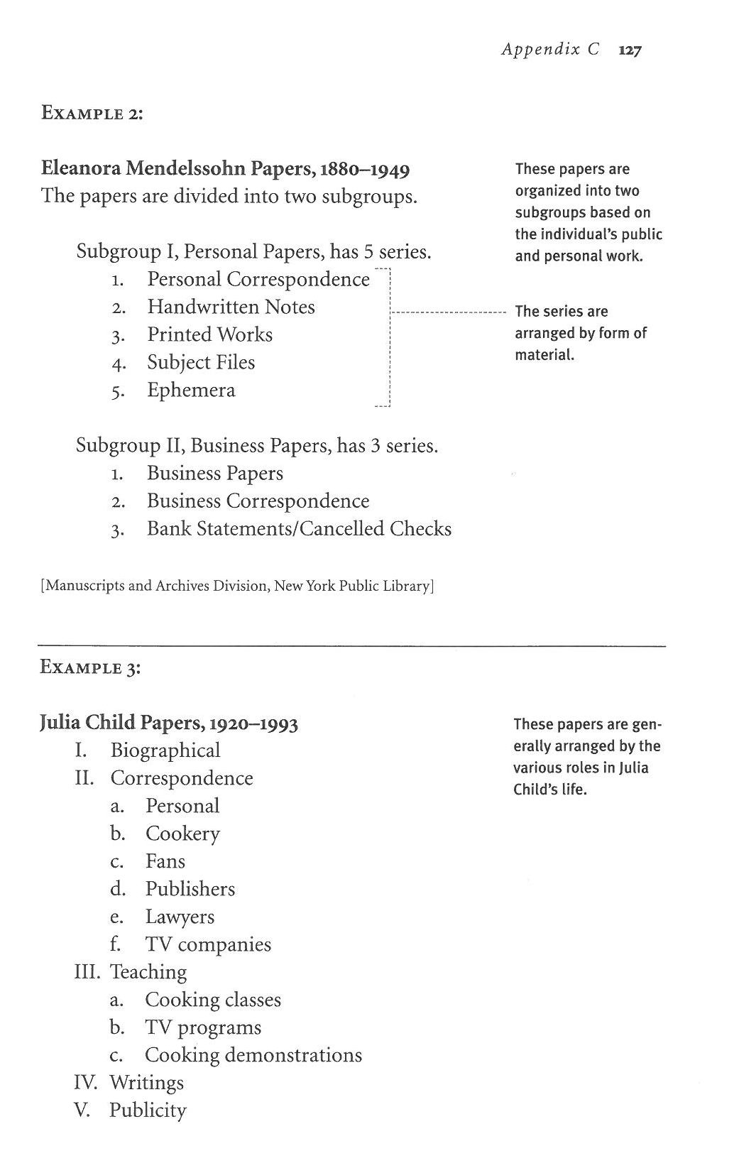

.
Organizational/Business Records
Source: Arranging & Describing Archives & Manuscripts by Kathleen D. Roe
Reprinted with permission of the Society of American Archivists.

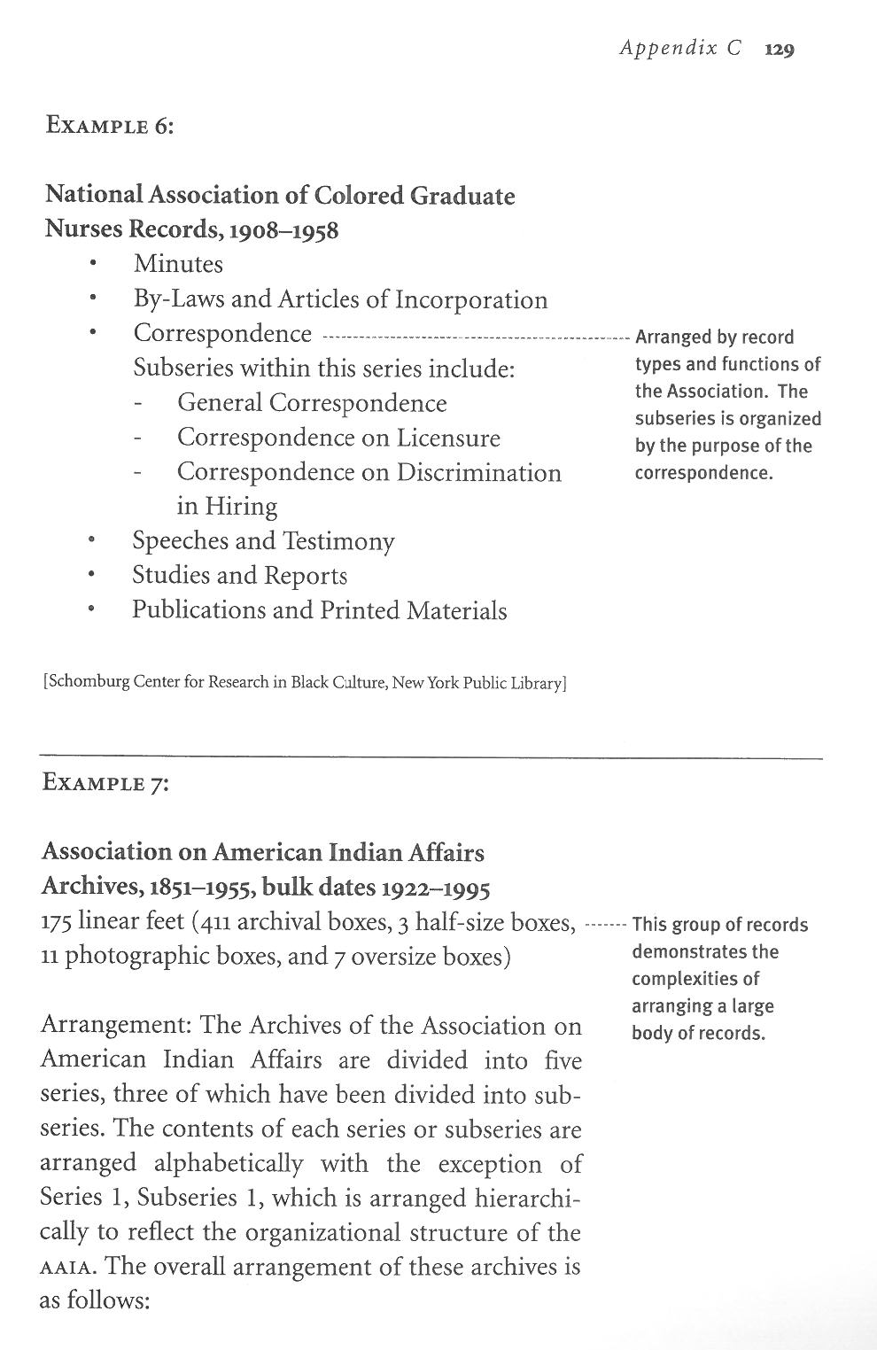
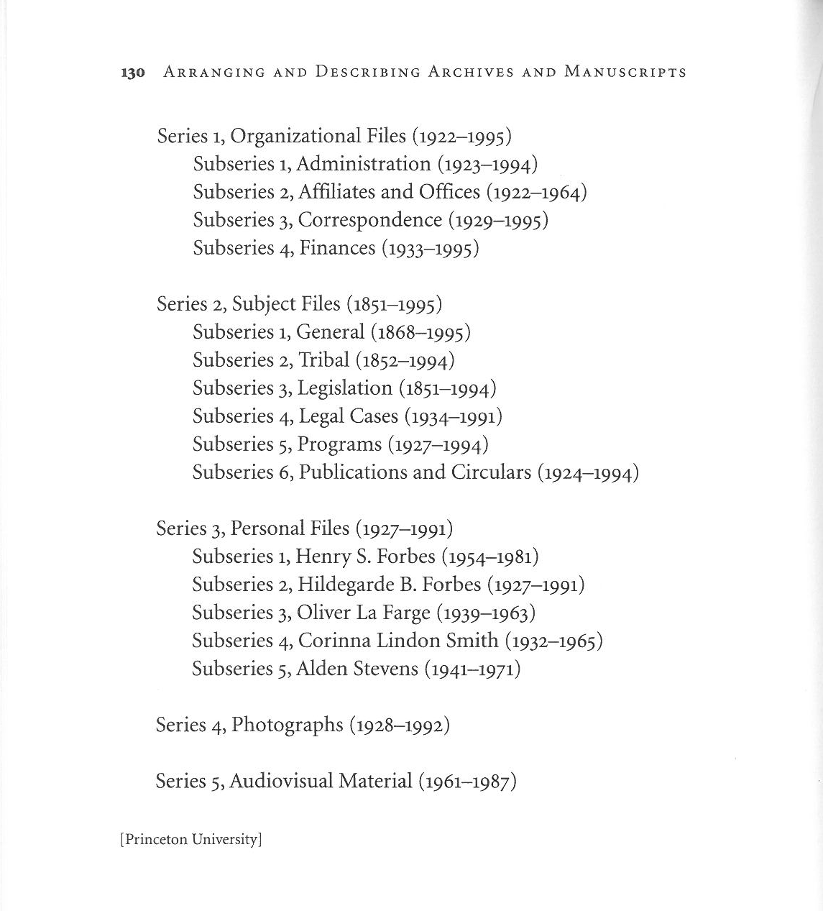
Arrangement of Specific Record Types

Audiovisual materials
When processing the collection, sort AV formats by type and list them using whatever information can be determined from physical examination of the materials or accompanying documentation (i.e., item count, format, title information). Depending on the nature of the content, arrange in chronological order or by the title of the item.

Common types:
Sound recordings
Audio cassettes
Compact discs
Reel-to-reel tapes
Phonograph records
Motion picture films
Video recordings
VHS
Betacam
U-Matic
Digital versatile discs

Photographs
Usually organized by subject matter, with unidentified items listed at the end of each grouping. Sometimes photographs are organized by type of photographic process, especially when dealing with vintage prints (daguerreotypes, tintypes, cartes de visite).

Commonly used categories:
Portraits [of creator]
Family
People
Identified people
Unidentified people
Places
Identified places
Unidentified places
Events
Photograph albums

Printed material

Common types:
Printed material by [creator]
Articles
Newspaper clippings

Printed material about [creator]
Articles
Newspaper clippings
Promotional material
Reviews
Other printed material

Writings [manuscripts/typescripts]

Common types
Writings by [creator]
Notebooks
Type of writing [poetry, prose, translations, etc.]
Writings about [creator]
Writings by others

Additional/Other papers [Miscellaneous papers]
Used to classify miscellaneous papers that do not logically belong in any of the otherwise established series or subseries, but are being retained. Usually these papers are arranged alphabetically by type of material.
Electronic Records

What are electronic records?
Electronic records most often refers to records created in electronic format (born digital), but is sometimes used to describe scans of records in other formats such as photographs, maps, etc.

Material type | Analog formats | Digital formats
Architectural records | Blueprints, evaluations, renderings | Computer-aided design (CAD) files
Correspondence | Letters, postcards | Emails, word processing files, social media
Data | Lab notebooks, logbooks, ledgers | Spreadsheets, databases
Institutional records | Typed or print documents | Word processing files, PDFs, databases
Manuscripts | Handwritten or typed documents, diaries | Word processing files, Facebook posts, blogs
Moving images | Film, video | DVDs, digital video files
Photographs | Film-based media such as prints, negatives, slides | Digital image files, Flickr, Instagram photos
Publications | Brochures, newsletters, reports | Websites, desktop publishing files
Sound recordings | Tapes, LPs, wax cylinders | CDs, digital sound files

Major differences between traditional paper-based collections and born-digital records stem from:

- wide range of file types
- the sheer volume of born-digital material, and the
- difficulties inherent in viewing the contents

OCLC's, "You've Got to Walk Before You Can Run: First Steps for Managing Born-Digital Content Received on Physical Media" advocates:

- Do no harm (to the physical media or the content).
- Don’t do anything that unnecessarily precludes future action and use.
- Don’t let the first two principles be obstacles to action.

General steps which most institutions, even those with limited resources, can do:

- inventory existing born-digital material and estimate the number of bytes;
- implement a storage solution, however imperfect, with the help or input of whatever IT resources are available;
- transfer records from disks to storage, while capturing authenticity information and documenting your activities; and
- begin formulating policies for future acquisition and preservation activities.

Doing nothing, will guarantee failure!

Born-digital records: Learn more about it!!

AIMS Work Group, "AIMS Born-Digital Collections: An Inter-Institutional Model for Stewardship," 2012. <http://www2.lib.virginia.edu/aims/whitepaper/>

Dooley, Jackie, "The Archival Advantage: Integrating Archival Expertise into Management of Born-digital Library Materials," 2015. <http://www.oclc.org/content/dam/research/publications/2015/oclcresearch-archival-advantage-2015.pdf>

Goldman, Ben, "Bridging the Gap: Taking Practical Steps Toward Managing Born-Digital Collections in Manuscript Repositories," RBM: A Journal of Rare Books, Manuscripts and Cultural Heritage, no.12, vol. 1 (2011): 11-24. http://rbm.acrl.org/content/12/1/11.full.pdf

OCLC, Demystifying Born Digital reports, various dates. http://www.oclc.org/research/themes/research-collections/borndigital.html

Prom, Christopher J. and Thomas J. Frusciano (ed.) Archival Arrangement and Description (Trends in Archives Practice). Chicago: Society of American Archivists, 2013.

Sorting

The process of physically arranging records can be as straightforward as verifying that the files in a collection are in good order or as complex as imposing an arrangement scheme on a collection that has no order. Based on the preliminary work plan, the archivist will process the collection to the appropriate level.

If extensive processing must be done, work from the highest arrangement level to the lowest. In other words, sort the materials first by record type or series. During the first sort keep material in their original folders. Once the first sort is completed concentrate on refining and completing each series/subseries before moving on to the next. For example, once all the correspondence is brought together, then arrange the individual pieces of correspondence into chronological or alphabetical order within the folders.

The processing archivist may find it easier to use the larger linear foot size boxes during the sorting process. To facilitate access to the collection, clip temporary box labels created on slips of paper on the outside of each box. Make sure the label includes the collection number, series title and box number.

Collecting Descriptive Notes during Processing

Careful note taking can facilitate the descriptive process that follows after arrangement.

Collect information on the:
- creator of the collection
- subject content
- functions documented
- major correspondents
- significant people, events, and places

Also note any:
- particular strengths
- weaknesses
- gaps

Although some of this information was probably already collected in the preliminary survey and research, the information will probably be expanded and updated through more careful examination of the materials.

Separating Materials

Different types of materials are often interfiled within a series. For access and preservation considerations, the following types of materials, among others, should be considered for separation:

- Photographs

- Audiovisual materials

- Electronic records

- Printed material [books and broadsides]

If an item is intricately related to another item in a series [e.g., a photograph attached to a letter], the archivist should create a separation form which documents the relationship between the two items. Any time materials are removed from their original place within a collection, record this information on a separation form. The original form stays in the item's original location and a photocopy of the separation form is filed with the item in its new location.

In the case of an audio or video recording which is accompanied by a letter, fill out the separation form and file it with the original letter and create a cross-reference note in the finding aid for the audio or video recording. For example [Originally filed in Series 1: Correspondence, Letter from April Chung to May Riley, January 24, 1999].

Most printed material can be left in the collection with the exception of published monographs. Printed monographs [books and broadsides] that will be more accessible if they are cataloged individually should be removed from the collection. If deemed appropriate, make a list of the authors and titles and place in collection folder.
Separation Sheet
[Source: Special Collections Research Center, Southern Illinois University Carbondale]

Category of item(s):
□ Audiocassette □ Printed materials
□ Electronic records □ Three-dimensional objects
□ Oversized materials □ Videotape
Photographs/negatives □ Other___________________

Number of items: 4_

Provide information about item(s) (for example, if a photograph identify as to size, content, and whether b/w or color)

Photographs of Elton John, 8 x 10, color

Related manuscript material also pulled? If so, please describe. ____________________________________________________________________________________________________________________________________________________________

Originally filed in:

Collection Name: John Rockstar papers

Series: Correspondence Subseries: Personal correspondence

Folder title: January-June 1974: Letter from Elton John to John Rockstar, January 28, 1974

Relocated to:

Series: Photographs Subseries:_____________________________

Folder title: John, Elton

Purpose of removal: _____________________________________________________

Date: April 12, 2015

Initials: PHD

Weeding

Much of an archivist's task consists of determining what material in a collection has enduring value. Any materials that are not deemed permanently valuable should be discarded or returned to the donor. When materials of questionable value are encountered, they should be set aside for further review making sure to note their original location. Materials that have been weeded from a collection should be placed in a discard box for deaccessioning. Do not discard weeded materials in the office trash; instead place discards in boxes and shred.

Try to retain no more than 2 copies (e.g., original and best copy) of any item in the collection. If checking multiple copies for (possible) minor variations proves to be simply too time consuming, retain all copies. Multiple copies are noted in the folder title after the main folder description. (e.g., Smith, John, The Thunder and the Rain [2 copies]). Extra copies should be put aside and retained until the collection is completely processed.

Applications
Ballots
Bank statements
Bills, Financial
Budget work papers
Business cards
Calendars, Desk
Cancelled checks
Carbon copies/Stencils
Cassette tapes [containing reproductions of commercially produced music, etc.] [copyright issues]
Claims
Copies of original materials held in other repositories
Drafts [of non-literary works]
Duplicate copies [only keep 2-3]
Forms [blank]
Greeting cards [if they only contain signatures]
Invoices
Leases
Letters, Form
Letters, Solicitation
Licenses
Manuals [owner]
Medical records [confidentiality issues]
Mortgages
Magazines [whole issues unless related to creator]
Newspaper clippings [unless related to creator]
Newspapers/newspaper clippings [unless related to creator]
Notes, lecture/class
Notes, research
Order forms
Payroll records
Phone messages
Postcards [blank]
Police accident reports
Purchase orders
Receipts
Requisitions
Sales literature/brochures/catalogs
Shorthand notes
Stationery [blank]
Supplies
Tax returns [confidentiality issues]
Tickets [airplane, events, speeding]
Travel brochures
Vouchers
Work orders
Worksheets

Restricting material
[Source: Beinecke Rare Book and Manuscript Library]

Access restrictions on processed collections are limited to specific items in a collection. Rarely is an entire processed collection restricted and in most cases the restriction is in place only for a limited period of time. Any restrictions (for privacy or preservation reasons) must be stated clearly in finding aids. Furthermore, any restricted content information must be kept in complete confidence by the processing staff.

Restricted materials must be:
- physically isolated in a separate box
- clearly stamped with the RESTRICTED stamp on the box label to avoid any unauthorized access
- If items are removed from an existing folder, a separation sheet should be completed and filed in the item's original location. Write the words "restricted material" in the "Description of Item(s)" section. A copy of the separation sheet should be clipped to the item that was moved to the restricted papers box.

Donor Imposed Restrictions
Papers of a personal or sensitive nature may be restricted for a specified time period, usually stipulated by the terms of the gift or purchase agreement.
- Restricted papers are listed on the finding aid either at the end of the respective series in which they belong or at the end of the finding aid. Box and folder numbers continue sequentially, as is the case for the rest of the collection. Restricted materials are not considered true series for series numbering purposes in the finding aid.
- Restricted papers may not always be fully described in the finding aid; in fact, sometimes they are not identified in any way but just noted as "Restricted."
- The level of description included in the finding aid should be consistent with the intent of the restriction; some materials are not to be made known in any form, just as Restricted Papers, whereas in other cases the nature of the material may be revealed (e.g., war diaries), but the materials themselves are withheld from use.
- If a collection includes these types of materials, add a Restrictions on Access Note to the finding aid and catalog record and be as specific as possible: Special restrictions apply: Series 1, correspondence is closed without the written permission of donor until December 1, 2025.

Archivist Imposed Restrictions - Fragile Materials
Materials being withheld from routine use because of their fragile physical condition are designated "Restricted Fragile."
- Surrogates (either preservation photocopies on lignin-free paper, or black and white or color photographic prints) are filed in the collection in place of the originals.
- The originals are then housed separately, as described in the section on packaging and listing "Restricted Fragile."

- If a collection includes these types of materials, add a Restrictions on Access Note to the finding aid: Due to the fragile nature of the [materials], researchers are required to use [e.g., photocopies, microfilm].

Archivist Imposed Restrictions - Protection of Privacy
Privacy is the right of an individual to be free from unwarranted publicity.
- Different kinds of invasions of privacy include intruding on a person's seclusion or private affairs, public disclosure of embarrassing private facts about an individual, and publicity that places a person in a false light in the public eye.
- You should be particularly alert to the privacy interests of third parties who are living or likely to be living, but who may not be aware that material relating to them (in particular, anything written by them) is now in a public research repository. According to the Code of Ethics for Archivists "archivists may place restrictions on access for the protection of privacy or confidentiality of information in the records."
- The library has a particular responsibility to identify potentially sensitive materials of this type and to take appropriate action. The course of action to be taken is decided by the archivist, in consultation with other library staff and university administrators, as appropriate.
- If the library decides to impose an access restriction on this basis, the decision should be fully documented. Copies of pertinent memos, etc., should be filed in the collection's file, in addition to any copies retained by the archivist.
- If a collection includes these types of materials, add a Restrictions on Access Note to the finding aid: Due to privacy concerns, some materials in the collection have been restricted.

Lifting Restrictions

Once the specified period for donor or archivist-imposed restriction has been completed, then the materials should be made available for research use.
- Update all records that cite restrictions including Restrictions on Access Note to the finding aid, catalog and EAD records and collection/donor files

File Folder Labeling

File folder tab

Last name/MSS# Contents 1 / 1
Series/Subseries title

Tips and tricks

Since you will most likely alphabetize by the first word in the folder title – make sure that it conveys the content.
Georgia Power Company annual report, 1966
not: Report of the Georgia Power Company, 1966

Capitalize the first word in each folder. Then capitalize only proper names or titles of works in the remaining folder title.
Annual financial reports, 1932-1935
not: Annual Financial Reports, 1932-1935

No punctuation at the end of the folder title.

Use proper diacritics when needed [e.g., Federico García Lorca]

Spell out acronyms
American Civil Liberties Union [ACLU]
not: ACLU

Limit the use of abbreviations in folder titles.
19th Georgia Infantry Regiment
not: 19th Ga. Infantry Regt.

Include full dates in folder titles, whenever possible and applicable.
March 13, 1966 no date or undated
not: 3/13/66 or Mar. 13, 1966 not: n.d.

If the original folder contains too much material to fit into a single new folder, or if a manuscript of a work is too large to fit in a single folder use [1 of 2], [2 of 2], etc. at the end of the folder title in brackets.
The Tain, galley proof [1 of 2]
The Tain, galley proof [2 of 2]

If you have retained multiple copies of a single item, note the number of copies at the end of the folder title in brackets: [2 copies].
Southern Changes, Southern Regional Council, Volume 1, Number 1 [2 copies]

If the item(s) in a file folder are photocopies of originals convey this at the end of the folder title in brackets: [photocopies].
Last will and testament, William L. Corbin, June 3, 1802 [photocopy]

Ignore articles (a, the, etc.) when filing folders in alphabetical order.

Personal names
Last name, first name
Smith, John
Add titles etc. in parenthesis after the inverted name
Smith, John (Mrs.)

Format the following in italics
A book, a periodical (magazine), a play, a newspaper, a movie, a ship

Format the following in quotation marks
A poem, an article title, a short story, a skit, a chapter, a newspaper story

"See" and "See also" references
"See" references point to material located elsewhere. Enclose this information in brackets, to denote that the archivist is adding this information.
[See Subseries 1.2: Blane, Jasper]

"See also" references provide a link from the listed material to other closely related material located elsewhere in the collection. Enclose this information in brackets, to denote that the archivist is adding this information.
[See also Subseries 2.1: "Lessons from Home"]

Cross-reference to a series/subseries number or title and folder title, never to a specific box and folders number – they change.

Variant titles
Use to express if a poem or work was also known under another title. Enclose this information in brackets, to denote that the archivist is adding this information.
"Banker's Ode" [variant title: "Ode to a Banker"]

Includes
Use to express that a single sheet of paper includes multiple poems. Enclose this information in brackets, to denote that the archivist is adding this information.
"Quatro poems" [includes "Desk," "Fly," "Shoe," and "Heel"]

Additional Techniques

Minimal Processing
(also referred to as MPLP or “More Product, Less Process”)

 | Processing Steps | Traditional | MPLP
Arrangement | Un-foldered material into folders | Yes | Yes
 | Folders into series | Yes | Maybe, if size/complexity of collection warrants
 | Folders within series | Yes | No
 | Items within folders | Yes | No
Description | Collection/Record Group | Yes | Yes
 | Series | Yes | Maybe, if size/complexity of collection warrants
 | Folders | Yes | May list, not describe
 | Items | May list or describe | No
Preservation | Re-box | Yes | Yes
 | Re-folder | Yes | Only if original folders are brittle or damaged
 | Remove fasteners | Yes | No
 | Separate and/or photocopy clippings, carbons, onionskins | Yes | No
 | Separate and/or sleeve photographs | Yes | No
 | Encapsulate or mend torn documents | Yes | No
 | Interleave scrapbooks and photo albums | Yes | No
Adapted from "How to Get More "Product" While Doing Less "Process," by Janet Hauck, Archival Outlook, (May/June 2008): 6-7. [Table originally provided courtesy of Mark Greene and Dennis Meissner, 2005]

Preservation During Processing
[Source: Wright State University Libraries, Special Collections & Archives]

Preservation is an ongoing activity that begins at the time a collection arrives and continues even after processing is completed. Preservation tasks aim to stop, prevent, or slow deterioration of archival materials, as well as to improve the condition of the item. Preservation may involve transferring information to a different format to preserve the intellectual content.

Cleaning and Repair
- Soft cloths or brushes can be used to wipe excessive dust and dirt from individual items. Be sure to brush dirt into a box, and wear a mask if necessary.
- Do not use pressure sensitive tape to repair documents. Consider placing the item in a polyester L sleeve or give to the Preservation Manager for possible mending.
- Encapsulation is especially useful for fragile oversize items.
- Never do anything to a document that is not reversible.

Remove Rubber bands, ribbon, twine, plastic folders, and vinyl binders

Post-it Notes
Post-it notes should not be used on any item of known permanent value. Aging tests indicate that the note's color tends to transfer to the sheets on which the notes are fixed. Adhesive residue from the note may remain on the sheet after the note is removed. Attempts to rub off the residue will do more harm than good, as the adhesive becomes more embedded in the material to which it has been attached. The adhesive can also lift fragile emulsions on photographs. Use of self-stick notes should be limited to non-valuable, non-archival materials. Strips of acid-free paper may be used in place of post-it notes for most archival processing needs.

Acidic Paper
Newsprint, manila paper, and construction paper are extremely acidic. They darken with age, become brittle, and stain papers with which they come in contact. Documents printed or written on thermal fax paper fade over time. More examples of acidic paper include telegrams, carbons, and school writing tablets.

Text on highly acidic paper should be photocopied onto acid-free paper. If there are great quantities of photocopying to do, give it to a student assistant to work on over time. Be sure that all of the material is relevant to the collection BEFORE making preservation photocopies.

When photocopying articles, be sure to transfer the name of the periodical, date and page number of the article onto the photocopy in square brackets. Also be sure that the entire article is copied, and no words are inadvertently cut off during copying. Discard the original item unless it has value as an artifact or exhibition, or is handwritten. If keeping the original, it can be placed in a polyester sleeve with a sheet of acid-free paper as a neutralizing backing, or simply interleaved with acid-free paper and placed in its own folder behind the preservation copy.

Metal Fasteners
Metal fasteners of any type should be removed. Two exceptions to this rule are staples in good condition and certain rivet or grommet fasteners that can result in damage to the paper if removed. In these cases, leave the fastener alone.

To remove staples use a micro spatula or flat (non-clawed) staple remover. Slide a small strip of polyester under the prongs of the staple on the back and carefully bend each prong up with the spatula. Then turn the document back over and lift the staple out from the front with the micro spatula. Metal fasteners may be replaced with stainless steel paperclips over a strip of alkaline paper. For groups of thicker items, use sheets of paper or large envelopes to keep sets of material together within a folder.

Folded and Rolled Documents
Carefully unfold and flatten folded documents. If there is great resistance to unfolding an item, do NOT force it open. Consider humidification. If a document is too large for a legal-size folder and too valuable to remain folded, transfer it to a map case drawer.

Photographs
Place photographs in polyester or polypropylene sleeves. Place negatives in acid-free paper envelopes. Interleave albums and scrapbooks with acid-free paper when necessary.

Fragile Items
Place fragile items in polyester sleeves or encapsulate when necessary. For added support, place a piece of acid-free mat board cut to size behind the item.

